4.9 Newton’s Method

Motivation: Suppose we wish to find positive root of the function to a high level of accuracy.
We can easily see that the positive root is but we want to have a decimal approximation of this number that is very accurate.
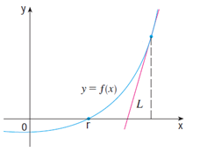
2
We would like to start with an easy guess as to what the value might. If we find the tangent line to the curve at our guess, and since the tangent line approximates the curve the x-intercept of the line should roughly be the same as the x-intercept of the curve.

Let’s suppose that we start by guessing that 2 is the positive root of .
We will try to find the tangent line to at .

We have the point
We know that
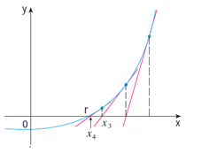
Therefore the equation of the tangent line is .
2

Our approximation for the root is the x-intercept of this line. We calculate: .
We could then repeat this process to obtain an even better approximation of the root.

Note: In class we looked at a GSP demonstration of Newton’s Method.

The General Derivation of Newton’s Method

The main idea: We use tangent lines toto help find roots of .

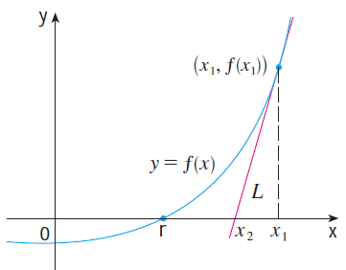
Let be our first approximation of the root r of .
We create a tangent line at :
We find the x-intercept of the this tangent line.
This x-intercept is our next approximate of the root r. So we say that (assuming )

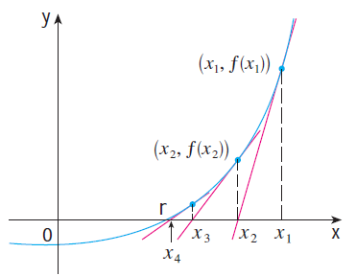
If we continue to repeat this process we create a sequence of approximations . In general the nth approximation is given by (assuming )

If as n becomes large the sequence becomes arbitrarily close to r then we say that converges to r and we write:

Note: The notion of the limit of a sequence is made precise in calculus II.

Note: Not all sequences of approximations will converge to r…we need to have a good starting approximation for .

Note: In more advance mathematics classes, namely numerical analysis, one can study conditions under which Newton’s method will be successful. In other words, we can make the idea of our initial guess being “sufficiently close” to the desired root precise. In this class we will not study such conditions. Rather, we will judge the reasonableness of our results by using the calculator.

Example 1: Starting with find the fourth approximation via Newton’s method to the positive root of the equation .

In this case we are seeking the positive zero of . We note that . So,
,
.

Therefore we estimate that the root of the function is .

Example 2: Starting with , find the 3rd approximation to the solution of the equation .

Newton’s Method helps us find roots of functions. Let . Notice that the root of this function will be the solution to the given equation.

If then

We calculate:
Therefore we estimate that the solution is

This process can also be complete using the calculator by doing the following:
- Type in your initial guess and store this value to A:
- Then on the calculator you enter:
- This will use the initial value to calculate and then change the value of A to this new value.
- Hit enter to obtain each new approximation.

Example 3: Find, correct to six decimal places, the solution of the equation .

Newton’s Method helps us find roots of functions. Let . Notice that the root of this function will be the solution to the given equation.

If then

We make an initial guess as to what the solution might be: (different start values are acceptable).

To use our calculator we store and then enter .
We obtain:

Therefore we estimate that the solution of the equation is .
Example 4: Use Newton’s method to find correct to six decimal places.

To approximate this value we need it to be the root of a function. Notice that is a root of the function .

Therefore, let and then .
We make our initial guess based on the fact that and that . So we guess that .
To use our calculator we store and then enter .
We obtain:

Therefore we estimate that .

